https://lucho.com/women-shoes/

Women shoes | https://lucho.com/women-shoes/ | ladies shoes  geto shoes  scarpin shoes  open toe shoes  open shoes for ladies  women's unique shoes  ladies shoes styles  ladies open shoes  peep toe shoes  ladies shoes design

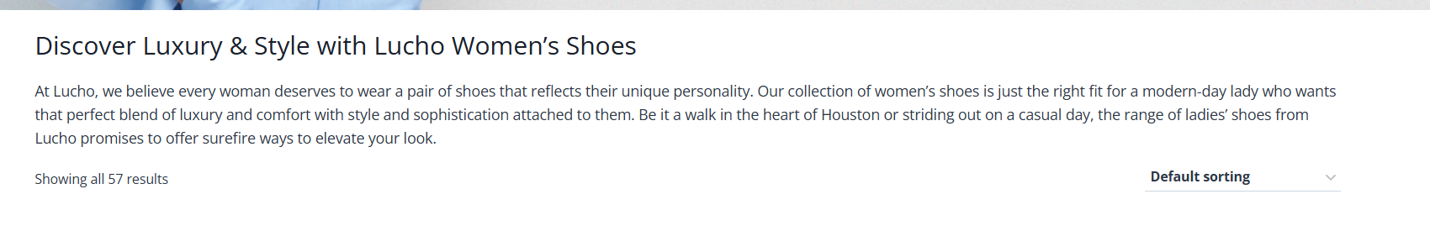

Discover Luxury & Style with Lucho Ladies Shoes
At Lucho, we believe every woman deserves to wear a pair of shoes that reflects their unique personality. Our collection of ladies shoes is just the right fit for a modern-day lady who wants that perfect blend of luxury and comfort with style and sophistication attached to them. Be it a walk in the heart of Houston or striding out on a casual day, the range of women's unique shoes from Lucho promises to offer surefire ways to elevate your look.

How Are Our Shoes Made?
At Lucho, each ladies’ shoe design is a piece of art, representing the best Italian craftsmanship. From open-toe to peep-toe, we design these style statements with expressions of luxury and details. We only utilize the best Italian materials to ensure that every step of our footwear showcases your brand. Whether you seek high-end sophistication or casual elegance, our exquisite collection provides a superior product encompassing the best of Italian craft culture.

From luxury ladies shoes to elegant women shoes who love to impress, we have everything that you want in design for each special occasion. Each of our pieces is designed in such a manner as to ensure optimum comfort while making sure your sense of style outshines the rest. Let experience grace from our unique ladies shoes styles and let Lucho be your home of the most special footwear in Houston.

Explore Our Ladies Shoe Collection:

To kick start your shopping, Lucho’s exquisite ladies shoe collection is ready to satisfy your desire for timeless chic blended with fashion. Check out the latest offers on shoes that will add the final touch in your personality and complete your outfit.

- Geto Shoes: Select the stylish and big geto shoes of Lucho with high quality craftsmanship and luxurious materials which can be used in formal occasions.
- Scarpin Shoes: Discover more about our scarpin shoes, a versatile and classy collection suitable for any woman’s wardrobe and suitable for any occasion.
- Open Toe Shoes: Explore the spirit of summer with our beautiful and sophisticated collection of ladies open shoes perfect to wear on any occasion.
- Peep Toe Shoes: Stand out in style when wearing our peep toe shoes, a style that looks classy but also adds a bit of style and power to the personality.

FAQ’s

Where is Lucho shoe manufactured?
Every one of the ladies' shoe designs in Lucho is the epitome of the best Italian-made shoes. Our open-toe, peep-toe, and other styles are created with very carefully chosen ornamentation. Our materials come from Italy, and the techniques are mastered to employ the best of Italian craft culture in our product.

What kinds of shoes are there for women at Lucho?
Lucho offers a variety of ladies' shoes, such as geto shoes, scraping shoes, shoes with open toes, and shoes with peep toes. These stylish and all-purpose designs are appropriate for many forms and trends.

Are Lucho lady's shoes different from others?
Of course, our ladies' shoes come in styles and unique designs. Choose the pair that best suits your personality.

Are Lucho's ladies' shoes appropriate for wear during formal occasions?
Yes, our ladies are suitable for formal wear and, therefore, especially appropriate for women who have special events to attend.

What makes Lucho's open shoes for ladies unique?
Lucho's open shoes for ladies are one of a kind, embodying the philosophy of Italian luxury, art, and quality material to distinguish itself from other brands. African over-toe shoes for women, including open-toe and peep-toe shoes, come with additional details and better designs suitable for most occasions.

How do I get the proper ladies' shoe style at Lucho?
Lucho has all kinds of shoes: open, peep-toe, and scraping. This means that when you browse our collection, you can find a preferred style. Moreover, we have various choices that suit every woman's personality type.

